Lyce Rohde
DAE 315, April 2, 2014

Native American Rattles
Age 6&7, Grade 1

I. Standard:
1. MDE Visual Arts Standard/s:

ART.VA.II.1.2 Explore the use of knowledge of the elements of art.
ART.VA.V.1.1 Recognize art forms created for functional and recreational purposes.
ART.VA.IV.1.3 Give examples that illustrate how artwork of different groups is influenced by the environment in which it was created

II. Objectives:
2. The Learner will– be able to construct a paper Mache rattle while employing their knowledge of Native American designs.
3. Learning Target– “I can create a rattle using the designs that Native Americans use on their own objects.”
4. How the objectives will be measured – A completed paper Mache rattle that is in the design of Native American crafts using line, shape, color and symbols.

III. Behavior Management:
5. Expectations, consequences, grouping, arrangement of furniture and supplies:
-Expectations: Using materials properly, no flinging the Paper Mache Paste, only coloring the cup, not touching the hot glue gun
-Grouping: Students will sit eight to a table
-Supplies: teacher will hand out the supplies to each student
-Technology: Native American designs will be shown to the students on the SmartBoard

IV. Anticipatory Set/Motivation:
6. Focus attention on the topic and connect learning: connected to prior knowledge because they are performing a play in their music class and will be using the Native American Rattles during the play. They will have drawn designs before and now will use their knowledge of shapes to draw the designs.
7. Review previous related concepts or processes:
- Be able to squeeze the Paper Mache paste between their fingers to get rid of the excess paste from the paper towel.
- Fine Motor skills to smooth their cups and draw the designs all the way around the cups
-Review shapes and designs that would be appropriate as Native American designs
8. 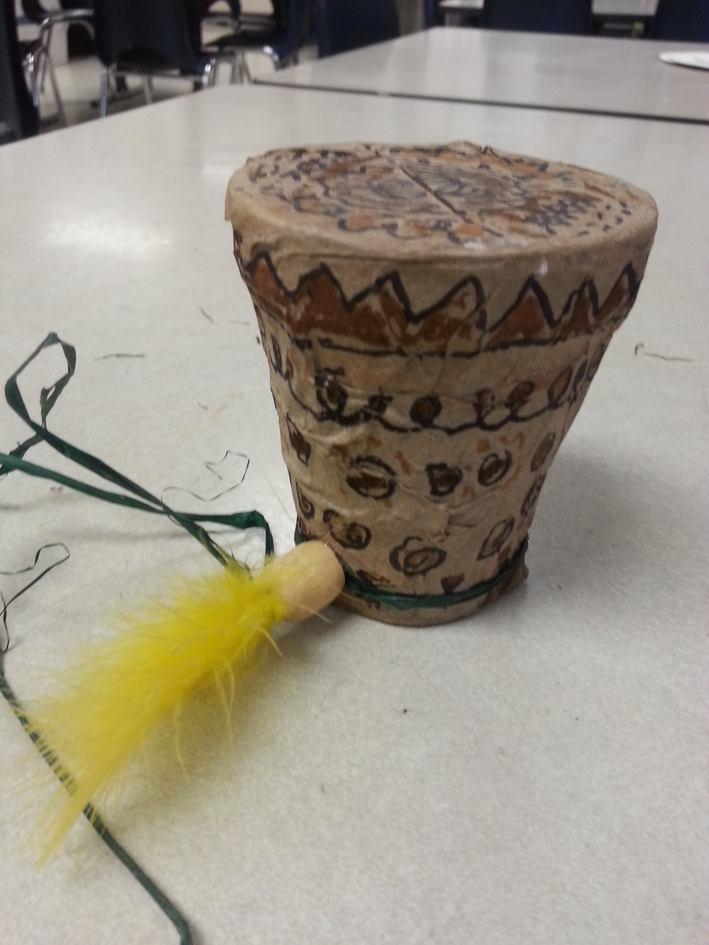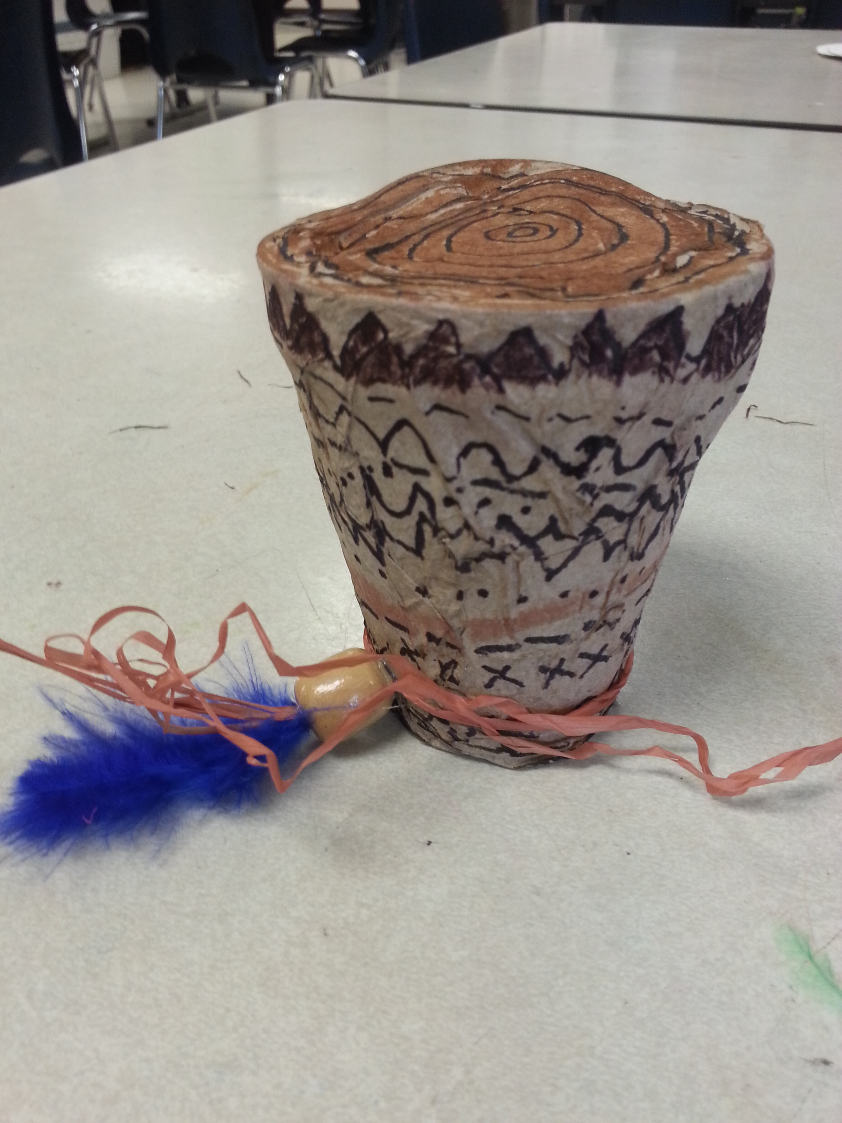
9. Books and materials:
-Show book that I made as an example of rattles and designs used by Native Americans.
-Google ‘Native American designs’ and ‘native American patterns’ and show those to the students
- find some books from the library on Native Americans and their patterns
McNutt, Nan, and Roger Fernandes. The Spindle Whorl: A Story and Activity Book for Ages 10-12, including a Teaching Guide. Portland, OR: WestWinds, 2011. Print.
Strauss, Susan, and Gary Lund. Coyote Stories for Children: Tales from Native America. Hillsboro, OR: Beyond Words Pub., 1991. Print.

V. Model the Process:
10. Criteria: A paper Mache cup that will be patterned with Native American designs in various shades of brown. Also raffia, a wooden bead and a feather will adorn the outside of the cup.
11. Task Analysis:
Demonstration: Demonstrate how to properly use the paper Mache and cover their cup
Guided Practice: How to draw the patterns and designs on the cup once they have the cup covered
Independent practice: Color in between the designs with the multicultural markers, also pick out their own wooden bead and piece of raffia
-teacher will use the hot glue gun to glue down the threaded wooden bead to the cup
12. Vocabulary: List 4 or 5 words:
Native American, Designs, Repetition, Line: straight, curve, angle, dotted
13. Materials: List specific tools:
- Styrofoam cups (one per child)
- Plastic lids (one per child)
- Plastic beads (four per child)
- Brown school paper towels made into strips
- Containers for paper Mache paste
- Paper Mache paste
- Multicultural Markers
- Sharpies (one per child)
- Raffia (one length per child)
- Wooden bead (one per child)
- Feathers (one per child)
-Hot Glue Gun (for teacher only)
14. Demonstration:
For the first part of the instruction (Paper Mache): All the students will gather around one table and the teacher will demonstrate how to paper Mache the cup with the teacher made cup. Dipping the paper towel into the paper Mache paste and using your pointer and middle finger to squeeze the extra paste from the paper towel. Then laying down the paper onto the cup and smooth down the paper. Making sure to point out that all the white of the cup needs to be covered with paper.
For designs and patterns: students will first look at different patterns and designs and the teacher will demonstrate how they are drawn, then the children will be able to use a sharpie to draw their own designs and patterns

VI. Check for Understanding:
15. Questions that relate to the objectives:
- What kind of design or pattern did you use on your rattles?
Where there triangles, circles or squares? Curved, dotted, straight lines?
- Did you use any symbols that Native Americans did not use? Why?
- How do Native Americans use the patterns and designs?

VII. Practice, Monitor and Adjust:
16. List the specific process sequence.
- Prepare beforehand each student’s cup, complete with name, beads and lid.
Day 1
- Introduce that we will be making rattles in a Native American design, which will then be used in their music play with the music teacher
- Call all student to the demonstration table
- Demonstrate how to properly use the paper Mache paste and cover the Styrofoam cup. Making sure to smooth each paper towel strip to mold to the cup.
*Do not cover up the bottom of the cup, otherwise we will not know whose cup is whose*
- Give each student a cup, it will have their name on the bottom, the plastic beads inside of them and the plastic lid on top
- Fill each large container with a little bit of Paper Mache paste and hand out to 2 per table
- Give each table a stack of paper towel strips (30 per table) to start off with, more can be given as needed
- Supervise the students and help where needed, especially with the smoothing out the cup process
- When the whole cup is covered and smoothed out, the cup rattles will be placed into a wax paper lined box until the next art class
- clean up
Day 2:
- Call all students to the demonstration table and have the students look at the various books that show Native American designs and patterns. Point out several designs
- Pull up images to display from google on the SmartBoard, of designs and patterns that are used by Native Americans on their own crafts
- Alongside these images, have a document open that will allow the teacher to show how these designs are drawn, and how simple it is to create these designs, if the student takes them one step at a time
- Start with passing out labeled cup rattles to the students
- Next each student is given a Sharpie and they start drawing their designs and patterns onto their cups
- Pass out Multicultural markers so that students can color in their shapes, making sure to remind them that not every part of the cup has to be colored in.
- When they are done adding color to their cups, they will come by the teacher and pick a piece of raffia and a wooden bead.
- The student will thread the raffia through the wooden bead as best as they can, if needed another student can help or the teacher, then pick out a feather from the feather bucket
- The teacher will use the Hot glue gun to glue the raffia and bead to the cup rattle and also glue the feather inside the bead opening
- Place finished cup rattles inside the box that they were gotten out of
-clean up

VIII. Accommodations/Differentiation:
17. For instruction and materials:
-Sensory issues: highly encourage students to use the paper Mache, if they absolutely cannot, ask if their neighbor (student) can help them
-Raffia and bead (putting them together) can be done by another student or by help of the teacher

IX. Clean-up:
18. Day 1: take large containers to the sink and stack next to each other instead of on top or inside of each other, throw away any wet paper towels, and take the dry paper towels and place them in the box with the other unused paper towels. There will be another box that is lined with wax paper that the teacher will place the wet cup rattles into to dry. *Kids are not allowed to wash their hands with paste on them, they need to use dry paper towels to rub all the paste off. Then let their hands dry the rest of the way. Only then can they wash their hands*
Day 2:
1 student from each table will be asked to put away their table’s multicultural markers
1 student from each table will be asked to collect their tables Sharpies and put them in the sharpie bin,
Each student will make sure that their cup rattle ends up back in the box that they did last week. This week it will no longer hold the wax paper and all the rattles that get put into that box will be dry
Any remaining paper scraps will be placed into the recycling bin
Teacher will put away Raffia box, wooden bead box, and feather box.

X. Closure:
19. Re-emphasize key learning: You have created a rattle using the Native American style designs and patterns.

20. Assessment:
Whole Group: Children will point to the answer on their cup
- What kind of design or pattern did you use on your rattles?
Where there triangles, circles or squares? Curved, dotted, straight lines?
Turn to neighbor and explain:
- Did you use any symbols that Native Americans did not use? Why?
- What do some of the symbols represent on Native American arts? Do those symbols represent the same meaning on your art?
Call on a student from each table to answer:
- Did we use materials that we can find in our school to make out rattles just like Native Americans used materials that they could find?
During Music Lesson: Functional and recreational purpose of rattles will be assessed.

