Lyce Rohde and Jane Plieth WING LAKE

Title of Lesson- Whoo Are You?
Grade Level- Special Education, ages 10-16, at a Kindergarten Level
Anticipated Time needed for entire lesson
45 minutes/ 1 class period
State Standards
ART.VA.I.K.3 Explore the elements of art through playful sensory experiences
ART.VA.II.K.2 Use a variety of lines, colors, and basic geometric shapes and patterns to creatively express feelings and personal experiences
Design/Critical Thinking Connection
Observation- What color are my eyes? And what is an owl?
Motor Skills- Can I grab something from a bag and place it onto my surface? Paint with a paintbrush?
Thinking- What color or textures am I grabbing?
Outcome (what is the desired result of the objective?)
Students will demonstrate the use of large and small motor skills in order to grasp and place objects on a glued surface. Students will also demonstrate the ability to use a paintbrush to paint specific parts of the owl. Students will also be able to use prior knowledge of their eye color to personalize the owl. It will be an expression of who they are in the representation of an owl.
Brief Description of Lesson
Students will use the elements of color, shape, and texture. Students will choose a template of an owl, then be able to pick out a variety of materials to glue onto their owl. These materials will be in different colors, shapes and textures. The students will then be asked what color their eyes are and use the corresponding color to paint the owl’s eyes. There will be a name plate attached to the bottom of the owl to identify which student has made the owl.

Scope and Sequence (ordered flow of lesson)
-Watch a short YouTube video to introduce owls and get the attention of the students (max. 5 minutes)
-Introduce the materials (2 minutes)
-Choose a precut owl body and correct name plate (2 minutes)
-Asking the children to identify the color of their eyes (5 minutes)
-with the help of Yes/No cards
-Using the correct color to paint in the eyes of the owl
-Applying glue with a brush to the owl (5 minutes)
-Application of materials to the body of the owl (15 minutes)
-Using hand over hand if necessary
-Attaching name plate to the body of the owl with precut pipe cleaners (5 minutes)
-Hanging the finished owl onto their cubbies (5 minutes)
Assessment (How will you measure the success of the outcome?)
-Was the student able to:
-identify their eye color
-use the paintbrush
-Grasp objects from the bag
-Apply objects to the body of the owl
-How to make it easier next time if not able to do some of the things listed above
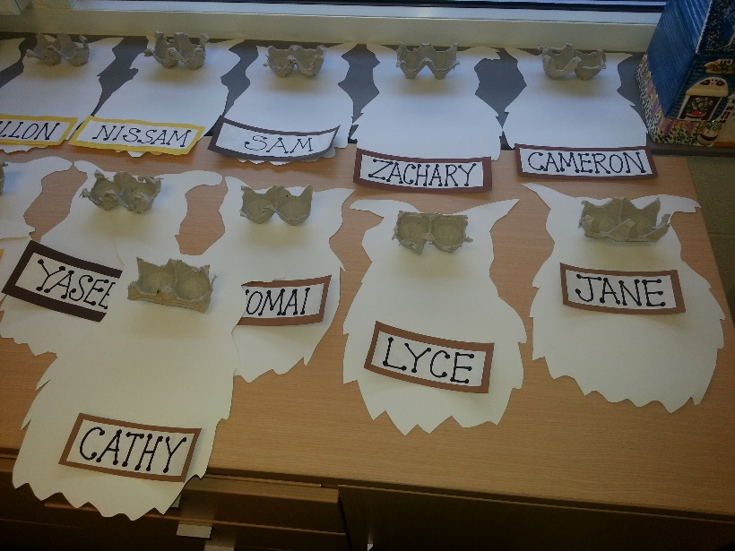
-Better time management? More or less time on certain aspects of the lesson?
Vocabulary (Essential Terms for the Lesson)
-Owl, Feather, Paper, Glue, Paint, Paintbrush, Color, Eyes, Texture, overlapping
Materials (What is needed to complete the lesson?)
-Egg Carton (precut for eyes)
-Posterboard (Precut owl shapes and Backing of name cards)
-Printer paper (For front of name cards)
-Marker (Name on namecard)
-Hot Glue Gun (Egg Carton sections to posterboard)
-Acrylic paint
-Paint brushes for glue and paint
-Pipe cleaners
-Feathers
-Paper scraps
-Fabric
-Ribbon
-Felt
-School Glue
-String
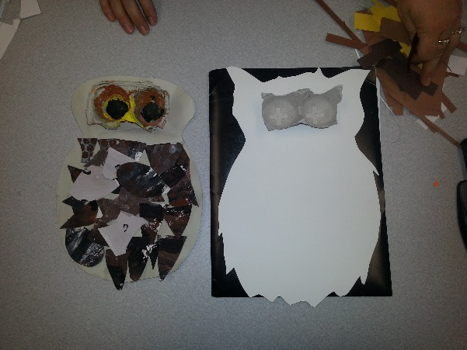
Pictures:
