Art Journals with Insert
High School, Grade 9-12
Mrs. Lyce Rohde

- Standard
  - C.1.1 Problem Seeking - engage in full interactive cycles of the artistic/creative process by problem seeking, exploring, making analytical, application, aesthetic, and design choices, before completion.
  - P.1.3 Principles - describe and consider relationships among the intent of the student/artist, the results of the artistic/creative process, and a variety of potential audiences or users.
  - R.1.4 Analyze - experience, analyze, and reflect on the variety of meanings that can be derived from the results of the artistic/creative process.
- Objective/benchmark
  - Students will be able to design and create a journal
  - Students will experience how to make a book using a book binding technique.
  - Students will need to use design thinking in producing the journal.
- Anticipatory set/ Motivation
  - Students will be expected to motivate and complete the project for a grade.
  - Basic skill of folding paper will be needed to finish the project.
  - Basic skills with a paintbrush to make abstract patterns.
  - Knowledge of book binding technique will be taught via demonstration, handouts and a PowerPoint presentation.
- Supply list
  - Drawing paper 14x17 or larger (4 sheets per student)
  - Ruler
  - Yes! Paste
  - Paintbrushes of various sizes
  - Water colors or Higgins India inks
  - Water containers
  - Bone folders
  - Book boards cut down to size of final journal size, sizes will vary per student (2 per student)
  - Book cloth for spine of journals
  - Xacto knives
  - 2D objects with personal or cultural significance
  - USB flash drives
  - String or stretchy cord to bind flash drive in insert
- Model the process
  - Criteria
    - A book no smaller than 3”x3” in size.
    - 10 page minimum in text block.
    - The pages and covers must be decorated.
    - Object must be adhered and inside the cutout of the book.
    - There must be a cohesive theme between the objects and the pages they are on
  - Task analysis
    - BELLWORK
      - What function do books have?
      - Name all the types of books you know. (not genres of literature)
    - Students will be given an instructional handout on the steps of the project
      - Thumbnail sketches for theme of book
      - Get approval of sketches
      - Student will be given 3 large pages
      - Color scheme that relates to the students theme need to be picked out
      - There will be mark marking exercises on all three sheets
      - Once dry, the sheets of paper need to be folded and divided to get specific size of paper
      - Pages now need to be folded and made into signatures
      - Decide the order of the pages
      - Lightly number the back of the pages
      - Signatures glued back to back in order, creating the text block
      - *make sure to keep the pages even with each other*
      - Flatten the text block with some weights for at least 10 minutes
      - Cut the size of book cloth needed to cover spine of book
      - Glue book cloth onto spine of book
      - Design the last piece of paper for the front and back cover of the book
      - Measure and cut book board 1/2 inch bigger than size of book
      - Decide what size the insert cut needs to be
      - Measure and cut out of front cover only
      - Glue the designed front and back paper onto the book boards
      - Glue the endsheets onto the back of the front cover and back cover
      - Write name on pastedown side of book
      - With pencil trace the insert onto first page
      - Cut out the tracing *make sure to have cardboard between pages*
      - Continue until at last page
      - Puncture 4 holes into the back cover, *WHERE THE INSERT IS*
      - Lace string through holes in pattern shown by teacher
      - Tie off the ends
      - Attach the USB drive into the journal
    - Students will be shown various examples of Artists Books via a computer projection and some physical examples
      - 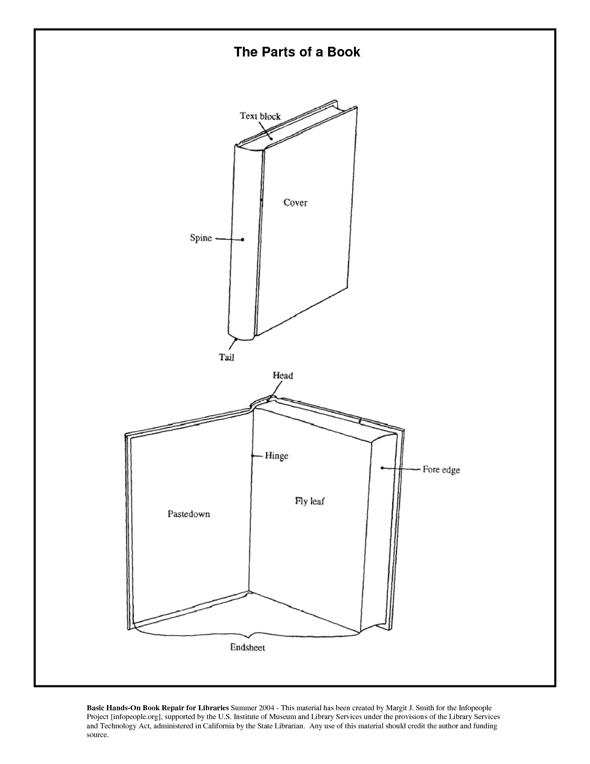
  - Vocabulary
    - Artist Book
    - Text Block
    - Binding
    - Case/cover
    - Spine
    - Design
    - Theme
    - End Sheets
    - Signatures
  - Demonstration
    - PowerPoint will be shown that introduces Artists Books and some examples of them, including the binding techniques
    - Teacher will demonstrate how to cut down paper sizes, bind the pages together, sample decorating the pages, cutting the cover for the journals and decorating them, assembling the text block to the covers, cut the box out of the book and attach the object to the book insert.
    - Questions?
- Check for understanding
  - See rubric for what is graded
  - Insert a quiz of vocabulary terms and techniques
- Monitor and adjust
  - Do students need help with gluing the pages together?
  - Do students have trouble with folding pages?
  - Can students work with xacto knives?
  - Additional time will be allotted or taken away as needed for the entire class based on progress.
- Accommodations
  - Accommodations will be made on a one to one basis as needed.
- Clean up
  - 5-10 minutes will be allotted each class period for cleanup.
- Closure and assessment
  - Students will be expected to complete the project in a timely manner.
  - Assessment will be based on:
    - completed projects, graded based on the rubric
    - quiz of vocabulary terms and techniques
- Grading rubric
  - see attached rubric and quiz

