NAME: ______________________ Hour: ___________
Project: JOURNAL WITH INSERT

RUBRIC:
Book bigger than 3”x3” in size ___/10 pts

At least 10 pages in text block ___/10 pts

Pages decorated ___/10 pts

Cover decorated ___/10 pts

Object fits inside cutout ___/10 pts

Object is secured ___/10 pts

Cohesive theme ___/10 pts

Craftsmanship ___/10 pts

Utilized class time appropriately ___/10 pts

___/10 pts

Comments:

TOTAL: ___/100 pts

Name: ________________ Hour: _______ Date: __________

QUIZ
Journal with Insert

Match the vocabulary word with the appropriate definition

- Artist Book ___ organization or structure of formal elements
- Binding ___ the fastening and securing of leaves in a book
- Design ___ works of art realized in the form of a book
- Theme ___ a central idea that something is based around

Label the parts of the book
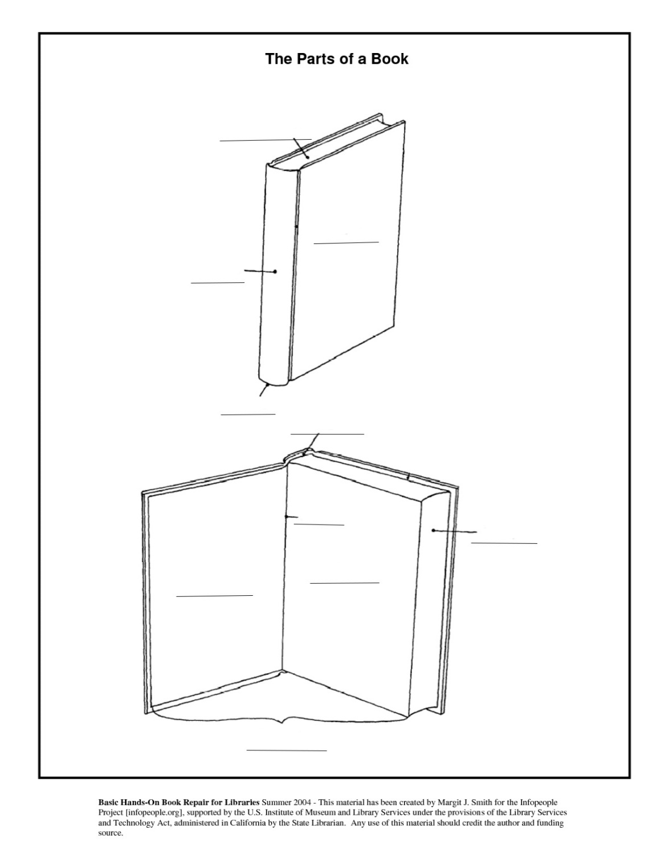

- Cover
- Text Block
- Spine
- Tail
- Head
- Hinge
- Fore edge
- Fly leaf
- Pastedown
- Endsheet

